**Bank Management System**

**Diagram: -**

**Modules:**

. Withdraw funds

-As a <customer> I want to <withdraw money from my account>So that<I get my money for needs with in less time>

-As a <customer> I want to <fast withdraws (500,1000) money from my account>So that <I get my money within 2 steps>

* The system should allow the user to enter the withdrawal amount.
* The system must verify that the withdrawal amount does not exceed the available account balance.
* After successful withdrawal, the account balance should be updated accordingly.

. Deposit funds

-As a <customer> I want to <deposit money to my account>So that<my money is safe in account >

-As a<Customer> I want to<deposit money saving account>so that <my money will add to that account>.

. Reconcile Account Balance

acceptance criteria:

* The customer needs to be logged in before depositing a check.
* The system should verify the amount written on the deposited check by asking the user.
* If the user agrees, the account balance should be updated and displayed.
* If the user disagrees, the system should eject the check back to the user.

. Pay A Bill

-As a <Customer> I want to<paying to daily bills>so that <I want to get benefit >

-As a <Customer> I want to <add money to wallet>so that < I want to pay without pin>

. Notifications

As a <customer> I want to <receive alerts and nonfictions activities>so that <I can know the important activities>

As a <customer> I want to <set automatic bills payments> so that<ii can ensure and pay my bills on time>.

Sprint:

In simplest words, “a sprint is a short and fixed time frame during which a specific set of tasks are meant to be performed”.  
An Agile project will be broken down into a certain number of sprints, each sprint lasting for a fixed duration of time. Usually, each sprint runs for 2–4 weeks. A **Sprint Planning Meeting** occurs before the start of every sprint. That meeting defines what set of items could be developed and delivered in the upcoming sprint.

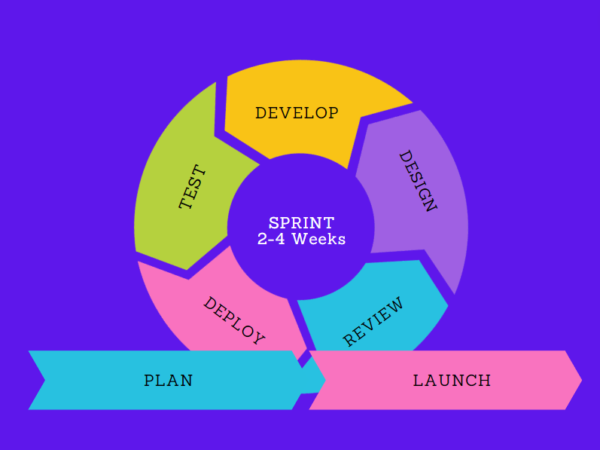

Sprint backlog- The Sprint Backlog is composed of user stories, tasks, bugs, or other work items that the development team has selected from the Product Backlog for inclusion in the current sprint. These items are chosen based on their priority and the team's capacity to complete them within the sprint's time frame.

Product owner- he Product Owner is responsible for communicating and maintaining the product vision. They work closely with stakeholders to understand their needs, gather requirements, and define the overall direction and goals for the product.

Scrum master- the Scrum Master plays a critical role in guiding and supporting the Scrum team, promoting Agile values and principles, and helping the team deliver high-quality products that meet customer needs.

Increment Development: Sprints promote incremental development, meaning that the work completed during each sprint adds value and contributes to the overall project progress. At the end of each sprint, there should be a potentially shippable product increment that can be demonstrated to stakeholders.

Daily scrum – The primary purpose of the Daily Scrum is to provide a brief opportunity for the development team to synchronize activities, discuss progress, and identify any impediments or obstacles that may be hindering progress towards the sprint goal.

* What did I accomplish yesterday?
* What will I work on today?
* Are there any impediments blocking my progress?

**Sprint Retrospective: –**-  Sprint Retrospective is to plan ways to increase quality and effectiveness.

This meeting is held after the sprint review meeting. In this meeting, all the team members including the Scrum Master and Manager discuss the following topics:

*1. The key takeaways from the sprint.*

*2. What things went well and what things didn’t ?*

*3. What problems were faced during the sprint ?*

*4. What other possible decisions could’ve been taken at that point.*

*5. Analysing the merits and demerits faced during the sprint.*

*Product backlong:*

A product backlog is a list of the new features, changes to existing features, bug fixes, infrastructure changes, or other activities that a team may deliver in order to achieve a specific outcome.

